[GOOGLE EARTH ENGINE](EE01%20Earth%20Engine%20(EE).docx) [APPLICATION PROGRAMMING INTERFACE](EE05%20%20%20The%20EE%20API.docx) [CAPABILITIES](EE07%20%20%20%20%20%20API%20Capabilities.docx)

PROCESSING **DATE** [PARAMETERS](EE26%20%20%20%20%20%20%20%20%20Parameters.docx)

A date is an Earth Engine parameter object that represents a point in time. Date can be processed by using operations of the types listed below, which vary according to the nature of that processing. Each operation name is linked to a separate page describing that operation.

**CREATING** DATES ee.Date ee.Algorithms.date ee.Date.fromYMD ee.Date.parse

**EDITING** DATES date.advance date.update

**REPRODUCING** DATES date.format date.millis date.getRange

**QUERYING** DATES date.get date.getFraction date.getRelative ee.Date.unitRatio

**COMPARING** DATES date.difference

**DOCUMENTING** DATES date.getInfo ee.Algorithms.Describe(confusionMatrix)

date.toString  date.serialize

**PRESENTING** DATES

IN **PRINT** print(date) console.log(date)

alert(date) confirm(date)

aside(func, var_args)

[GOOGLE EARTH ENGINE](EE01%20Earth%20Engine%20(EE).docx) [APPLICATION PROGRAMMING INTERFACE](EE05%20%20%20The%20EE%20API.docx) [CAPABILITIES](EE07%20%20%20%20%20%20API%20Capabilities.docx)

**CREATING** DATE [PARAMETERS](EE26%20%20%20%20%20%20%20%20%20Parameters.docx)

ee.Date and ee.Algorithms.Date both create a date object representing a specified point in time.

newDate = ee.Date( theDate*, timeZone* )

or ee.Algorithms.Date( theDate*, timeZone* )

The new date

A time zone to be assumed when **theDate** is specified as a string. Default: UTC

The specified date, given as a JavaScript Date object, a number (interpreted as milliseconds since the beginning of January 1, 1970),

or a string in YYYY-MM-DD, YYYY-DDD, or YYYY-MM-DD-TTTTTT format (such as '1996-01-01' or '1996-001' or '1996-01-01T08:00').

var HerDATE = ee.Date( '1950-09-18' );

var HisDATE = ee.Algorithms.Date( '1950-12-25' );

var TheirDATE = ee.Algorithms.Date( '1973-08-11' );

print( HerDATE, HisDATE, TheirDATE );

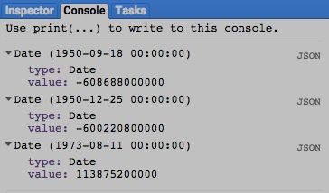

[GOOGLE EARTH ENGINE](EE01%20Earth%20Engine%20(EE).docx) [APPLICATION PROGRAMMING INTERFACE](EE05%20%20%20The%20EE%20API.docx) [CAPABILITIES](EE07%20%20%20%20%20%20API%20Capabilities.docx)

**CREATING** DATE [PARAMETERS](EE26%20%20%20%20%20%20%20%20%20Parameters.docx)

ee.Date.fromYMD creates a date from a specified year, month, and day.

newDate = ee.Date.fromYMD( theYear, theMonth, theDay*, timeZone* )

A time zone to be assumed, given as a string. Default: UTC

The specified year, given as an integer

The new date

The specified year, given as an integer of from 1 to 31

The specified year, given as an integer of from 1 to 12

var TheDATE = ee.Date.fromYMD( 1990, 7, 16 );

print( TheDATE );

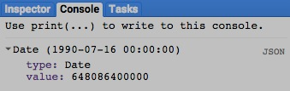

[GOOGLE EARTH ENGINE](EE01%20Earth%20Engine%20(EE).docx) [APPLICATION PROGRAMMING INTERFACE](EE05%20%20%20The%20EE%20API.docx) [CAPABILITIES](EE07%20%20%20%20%20%20API%20Capabilities.docx)

**CREATING** DATE [PARAMETERS](EE26%20%20%20%20%20%20%20%20%20Parameters.docx)

ee.Date.parse creates a date from a specified string in a specified format..

newDate = ee.Date.parse( theFormat, theString*, timeZone* )

A time zone to be assumed,

given as a string. Default: UTC

The specified

string

The specified format,

given as described [here](http://joda-time.sourceforge.net/apidocs/org/joda/time/format/DateTimeFormat.html).

The new

date

var TheDATE = ee.Date.parse( 'mm-dd-yyyy', '09-14-2015' );

print( TheDATE );

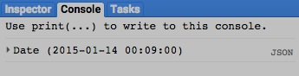

[GOOGLE EARTH ENGINE](EE01%20Earth%20Engine%20(EE).docx) [APPLICATION PROGRAMMING INTERFACE](EE05%20%20%20The%20EE%20API.docx) [CAPABILITIES](EE07%20%20%20%20%20%20API%20Capabilities.docx)

**EDITING** DATE [PARAMETERS](EE26%20%20%20%20%20%20%20%20%20Parameters.docx)

date.advance creates a new date by adding a specified number of a specified unit of time to a specified date..

newDate = oldDate.advance( amountOfAdditionalTime, unitsOfAdditionalTime*, timeZone* )

The pecified unit, given one of the strings ‘year’, ‘month’, ‘week’, ‘day’, ‘hour’, ‘minute’, or ‘second’.

The specified date

The specified

number of units

A time zone to be assumed,

given as a string. Default: UTC

The new date

var OldDATE = ee.Date( '1950-09-18' );

var NewDATE = OldDATE.advance( 1, 'week' );

print( OldDATE, NewDATE );

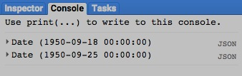

[GOOGLE EARTH ENGINE](EE01%20Earth%20Engine%20(EE).docx) [APPLICATION PROGRAMMING INTERFACE](EE05%20%20%20The%20EE%20API.docx) [CAPABILITIES](EE07%20%20%20%20%20%20API%20Capabilities.docx)

**EDITING** DATE [PARAMETERS](EE26%20%20%20%20%20%20%20%20%20Parameters.docx)

date.update creates a new date by changing one or more specified units of a specified date.

newDate = oldDate.update( *theYear, theMonth, theDay, theHour, theMinute, theSecond, timeZone* )

The new date

A specified minute,

given as an integer

A specified hour,

given as an integer

A time zone

to be assumed,

given as a string.

Default: UTC

A specified year,

given as an integer

A specified month,

given as an integer

The specified date

A specified second, given as an integer

A specified day, given as an integer

var OldDATE = ee.Date( '1990-11-04' );

var NewDATE = OldDATE.update( 2001, null, 9 );

print( OldDATE, NewDATE );

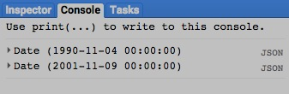 [GOOGLE EARTH ENGINE](EE01%20Earth%20Engine%20(EE).docx) [APPLICATION PROGRAMMING INTERFACE](EE05%20%20%20The%20EE%20API.docx) [CAPABILITIES](EE07%20%20%20%20%20%20API%20Capabilities.docx)

**REPRODUCING** DATE [PARAMETERS](EE26%20%20%20%20%20%20%20%20%20Parameters.docx)

date.format creates a new string representing a specified date in a specified format..

newString = oldDate.format( theFormat*, timeZone* )

A time zone to be assumed,

given as a string. Default: UTC

The specified format,

given as described [here](https://developer.gooddata.com/cloudconnect/manual/date-and-time-format.html).

The specified

date

The new

string

var TheDATE = ee.Date.fromYMD( 1990, 7, 16 );

var TheSTRING = TheDATE.format('MM-dd-yyyy' );

print( TheDATE, TheSTRING );

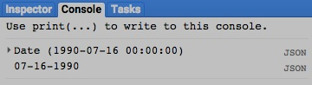

[GOOGLE EARTH ENGINE](EE01%20Earth%20Engine%20(EE).docx) [APPLICATION PROGRAMMING INTERFACE](EE05%20%20%20The%20EE%20API.docx) [CAPABILITIES](EE07%20%20%20%20%20%20API%20Capabilities.docx)

**REPRODUCING** DATE [PARAMETERS](EE26%20%20%20%20%20%20%20%20%20Parameters.docx)

date.millis creates a new number indicating the elapsed time in milliseconds from the start of January 1, 1970 to a specified date.

newNumber = oldDate.millis( )

The new number,

given as a long

The specified date

var TheDATE = ee.Date( '2015-12-25' );

var MillisecondNUMBER = TheDATE.millis( );

print( TheDATE, MillisecondsNUMBER );

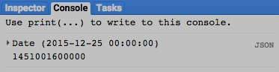

[GOOGLE EARTH ENGINE](EE01%20Earth%20Engine%20(EE).docx) [APPLICATION PROGRAMMING INTERFACE](EE05%20%20%20The%20EE%20API.docx) [CAPABILITIES](EE07%20%20%20%20%20%20API%20Capabilities.docx)

**QUERYING** DATERANGE [PARAMETERS](EE26%20%20%20%20%20%20%20%20%20Parameters.docx)

date.getRange creates a new date by adding a specified number of a specified unit of time to a specified date..

newDateRange = oldDate.getRange( unitOfTime*, timeZone* )

A time zone to be assumed, given as a string. Default: UTC

The specified date

The new

dateRange

The specified unit, given one of the strings ‘year’, ‘month’, ‘week’, ‘day’, ‘hour’, ‘minute’, or ‘second’.

var OldDATE = ee.Date( '1950-09-18' );

var NewDATERANGE = OldDATE.getRange( 'month' );

print( OldDATE, NewDATERANGE );

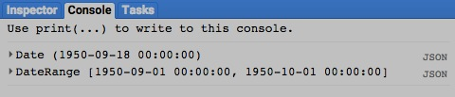

[GOOGLE EARTH ENGINE](EE01%20Earth%20Engine%20(EE).docx) [APPLICATION PROGRAMMING INTERFACE](EE05%20%20%20The%20EE%20API.docx) [CAPABILITIES](EE07%20%20%20%20%20%20API%20Capabilities.docx)

**QUERYING** DATE [PARAMETERS](EE26%20%20%20%20%20%20%20%20%20Parameters.docx)

date.get creates a new number indicating how many of a specified unit of time are associated with a specified date..

newNumber = oldDate.get( unitOfTime*, timeZone* )

The specified date

A time zone to be assumed, given as a string. Default: UTC

The new

dateRange

The specified unit, given one of the strings ‘year’, ‘month’, ‘week’, ‘day’, ‘hour’, ‘minute’, or ‘second’.

var OldDATE = ee.Date( '1950-09-18' );

var NewNUMBER = OldDATE.get( 'month' );

print( OldDATE, NewNUMBER );

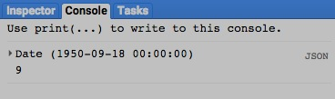

[GOOGLE EARTH ENGINE](EE01%20Earth%20Engine%20(EE).docx) [APPLICATION PROGRAMMING INTERFACE](EE05%20%20%20The%20EE%20API.docx) [CAPABILITIES](EE07%20%20%20%20%20%20API%20Capabilities.docx)

**QUERYING** DATE [PARAMETERS](EE26%20%20%20%20%20%20%20%20%20Parameters.docx)

date.getFraction creates a new number between 0 and 1 indicating what proportion of a specified unit of time has elapsed at a specified date..

newNumber = oldDate.getFraction( unitOfTime*, timeZone* )

A time zone to be assumed, given as a string. Default: UTC

The new number,

given as a float

The specified date

The specified unit, given one of the strings ‘year’, ‘month’, ‘week’, ‘day’, ‘hour’, ‘minute’, or ‘second’.

var OldDATE = ee.Date( '1950-09-18' );

var NewNUMBER = OldDATE.getFraction( 'month' );

print( OldDATE, NewNUMBER );

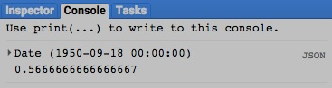

[GOOGLE EARTH ENGINE](EE01%20Earth%20Engine%20(EE).docx) [APPLICATION PROGRAMMING INTERFACE](EE05%20%20%20The%20EE%20API.docx) [CAPABILITIES](EE07%20%20%20%20%20%20API%20Capabilities.docx)

**QUERYING** DATE [PARAMETERS](EE26%20%20%20%20%20%20%20%20%20Parameters.docx)

date.getRelative creates a new number indicating, for a specified date, how many of a specified unit of time have elapsed within a larger specified unit.

newNumber = oldDate.getRelative( smallerUnitOfTime, largerUnitOfTime, *timeZone* )

The smaller of the two specified

units, given one of the strings

‘year’, ‘month’, ‘week’, ‘day’,

‘hour’, ‘minute’, or ‘second’.

The larger of the two specified

units, given one of the strings

‘year’, ‘month’, ‘week’, ‘day’,

‘hour’, ‘minute’, or ‘second’.

The specified

date

A time zone to be assumed,

given as a string. Default: UTC

The new number,

given as a long

var OldDATE = ee.Date( '2015-09-2' );

var NewNUMBER = OldDATE.getRelative( 'hour', 'month' );

print( OldDATE, NewNUMBER );

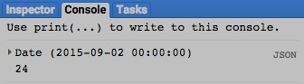

[GOOGLE EARTH ENGINE](EE01%20Earth%20Engine%20(EE).docx) [APPLICATION PROGRAMMING INTERFACE](EE05%20%20%20The%20EE%20API.docx) [CAPABILITIES](EE07%20%20%20%20%20%20API%20Capabilities.docx)

**QUERYING** DATE [PARAMETERS](EE26%20%20%20%20%20%20%20%20%20Parameters.docx)

ee.Date.unitRatio generates a number indicating the ratio of first to the second of two specified units of time..

newNumber = ee.Date.unitRatio ( numerator, denominator)

The ratio, given as a

floating-point number

The second of the two specified units of time,

given one of the strings ‘year’, ‘month’,

‘week’, ‘day’, ‘hour’, ‘minute’, or ‘second’.

The first of the two specified units of time,

given one of the strings ‘year’, ‘month’,

‘week’, ‘day’, ‘hour’, ‘minute’, or ‘second’.

var TheNUMBER = ee.Date.unitRatio( 'month', 'year' );

print( TheNUMBER );

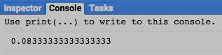

[GOOGLE EARTH ENGINE](EE01%20Earth%20Engine%20(EE).docx) [APPLICATION PROGRAMMING INTERFACE](EE05%20%20%20The%20EE%20API.docx) [CAPABILITIES](EE07%20%20%20%20%20%20API%20Capabilities.docx)

**COMPARING** DATE [PARAMETERS](EE26%20%20%20%20%20%20%20%20%20Parameters.docx)

date.difference creates a new number indicating the amount of time in specified units from one specified date to another.

newNumber = oldDate.difference( startingDate, unitsOfTime)

The specified

starting date

The pecified unit, given one of the strings ‘year’, ‘month’, ‘week’, ‘day’, ‘hour’, ‘minute’, or ‘second’.

The specified

ending date

The new number,

given as a float

var StartDATE = ee.Date( '2015-09-18' );

var StopDATE = ee.Date( '2015-12-25' );

var DaysNUMBER = StopDATE.difference( StartDATE, 'day' );

print( OldDATE, NewDATE, DaysNUMBER );

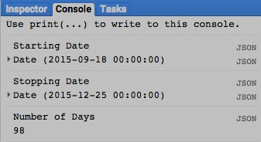[GOOGLE EARTH ENGINE](EE01%20Earth%20Engine%20(EE).docx) [APPLICATION PROGRAMMING INTERFACE](EE05%20%20%20The%20EE%20API.docx) [CAPABILITIES](EE07%20%20%20%20%20%20API%20Capabilities.docx)

**DOCUMENTING** DATE [PARAMETERS](EE26%20%20%20%20%20%20%20%20%20Parameters.docx)

ee.Algorithms.Describe and date.getInfo

each creates a JSON-compatible text object representing a specified date.

newObject = ee.Algorithms.Describe( oldDate )

and oldDate.getInfo( )

The specified date

The new object

var TheDATE = ee.Date( '1950-09-18' );

print( 'From print:', TheDATE );

print( 'From ee.Algorithms.Describe( ):', ee.Algorithms.Describe( TheDATE ) );

print( 'From getInfo( ):', TheDATE.getInfo( ) );

[GOOGLE EARTH ENGINE](EE01%20Earth%20Engine%20(EE).docx) [APPLICATION PROGRAMMING INTERFACE](EE05%20%20%20The%20EE%20API.docx) [CAPABILITIES](EE07%20%20%20%20%20%20API%20Capabilities.docx)

**DOCUMENTING** DATE [PARAMETERS](EE26%20%20%20%20%20%20%20%20%20Parameters.docx)

date.toString and .serialize each creates a new string presenting information on a specified date.

newString = oldDate.toString ( )

and oldDate.serialize( )

The specified date

The new string

var TheDATE = ee.Date( '1950-09-18' );

print( 'From print:', TheDATE );

print( 'From toString( ):', TheDATE.toString( ) );

print( 'From serialize( ):', TheDATE.serialize( ) );

[GOOGLE EARTH ENGINE](EE01%20Earth%20Engine%20(EE).docx) [APPLICATION PROGRAMMING INTERFACE](EE05%20%20%20The%20EE%20API.docx) [CAPABILITIES](EE07%20%20%20%20%20%20API%20Capabilities.docx)

**PRESENTING** DATE [PARAMETERS](EE26%20%20%20%20%20%20%20%20%20Parameters.docx) IN **PRINT**

print ( date ) and console.log ( date ) present JSON-formatted text renditions of a specified date in the console.

print( oldDate ) or console.log( oldDate )

The specified date

var TheDATE = ee.Date( '1950-09-18' );

print( 'From print:', TheDATE );

console.log( 'From console.log:', TheDATE );

[GOOGLE EARTH ENGINE](EE01%20Earth%20Engine%20(EE).docx) [APPLICATION PROGRAMMING INTERFACE](EE05%20%20%20The%20EE%20API.docx) [CAPABILITIES](EE07%20%20%20%20%20%20API%20Capabilities.docx)

**PRESENTING** DATE [PARAMETERS](EE26%20%20%20%20%20%20%20%20%20Parameters.docx) IN **PRINT**

alert ( date ) and confirm ( date ) present JSON-formatted text renditions of a specified

date in a pop-up message box.

alert( oldDate ) or confirm( oldDate )

The specified date

var OldDATE = ee.Date( '1950-09-18' );

alert( OldDATE );

confirm( OldDATE );